а)

Вариационный ряд

17.0, 17.0, 17.0, 17.0, 17.0, 18.0, 18.0, 18.0, 20.0, 20.0,

20.0, 20.0, 20.0, 20.0, 20.0, 22.0, 22.0, 22.0, 22.0, 22.0,

22.0, 22.0, 22.0, 22.0, 22.0, 22.0, 23.0, 24.0, 24.0, 24.0,

24.0, 24.0, 24.0, 24.0, 24.0, 24.0, 24.0, 24.0, 24.0, 24.0,

24.0, 26.0, 26.0, 26.0, 26.0, 26.0, 26.0, 26.0, 26.0, 26.0,

26.0, 26.0, 26.0, 26.0, 26.0, 26.0, 28.0, 28.0, 28.0, 28.0,

28.0, 28.0, 28.0, 28.0, 28.0, 28.0, 28.0, 28.0, 28.0, 28.0,

30.0, 30.0, 30.0, 30.0, 30.0, 30.0, 30.0, 30.0, 30.0, 30.0,

30.0, 30.0, 32.0, 32.0, 32.0, 32.0, 32.0, 32.0, 32.0, 32.0,

34.0, 34.0, 34.0, 34.0, 35.0, 35.0, 35.0, 35.0, 35.0, 36.0

б)

Xmin = 17.0

Xmax = 36.0

Размах = 19.0

h = 2.11

|  |  |  |  |  |  |
| --- | --- | --- | --- | --- | --- |
| *mi* | Границы интерва- ла *xi* ; *xi* + 1 | Середина интервала *x*′*i* | Частота интер- вала *ni* | Частость | Плотность частости |
| 1 | 17.00-19.11 | 18.05 | 8 | 0.8 | 0.04 |
| 2 | 19.11-21.22 | 20.16 | 7 | 0.7 | 0.03 |
| 3 | 21.22-23.33 | 22.27 | 12 | 0.12 | 0.06 |
| 4 | 23.33-25.44 | 24.38 | 14 | 0.14 | 0.07 |
| 5 | 25.44-27.56 | 26.5 | 15 | 0.15 | 0.07 |
| 6 | 27.56-29.67 | 28.61 | 14 | 0.14 | 0.07 |
| 7 | 29.67-31.78 | 30.72 | 12 | 0.12 | 0.06 |
| 8 | 31.78-33.89 | 32.83 | 8 | 0.8 | 0.04 |
| 9 | 33.89-36.00 | 34.94 | 10 | 0.10 | 0.05 |
| ∑  *i* | – | – | 100 |  | – |

в)

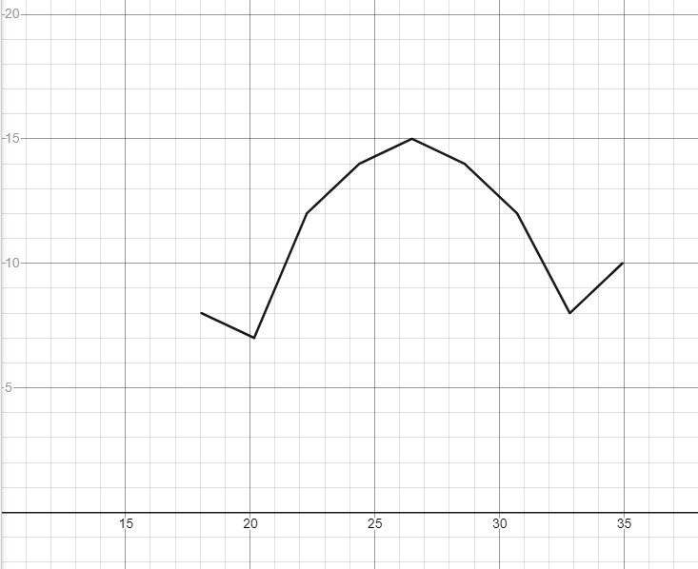

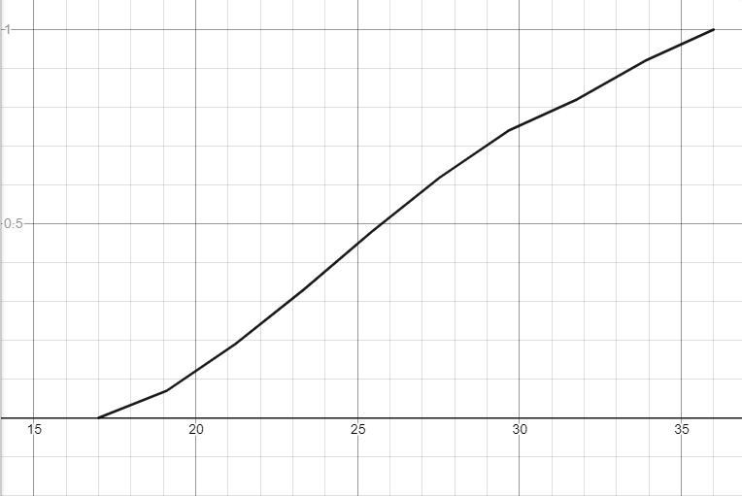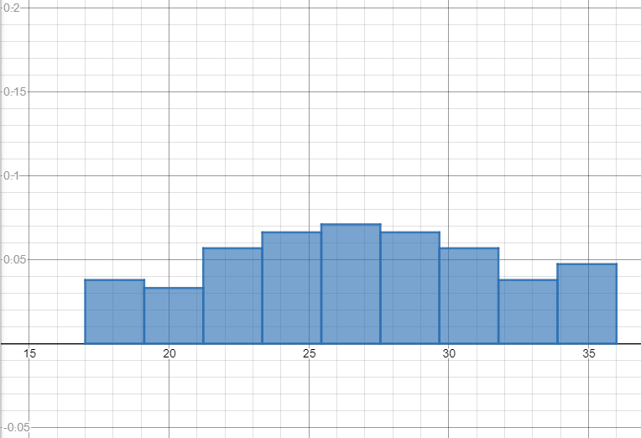

г)

x (среднее) = 25.67

Dв = 24.32

σв = 4.932

Dв = 24.56

σв = 4.95

|  |  |  |  |  |  |  |
| --- | --- | --- | --- | --- | --- | --- |
| *mi* | Границы интерва- ла *xi* ; *xi* + 1 | Середина интервала *x*′*i* | Частота интер- вала *ni* | *nix*′*i* | 2  (*x*′*i* ) | 2  *ni*(*x*′*i* ) |
| 1 | 17.00-19.11 | 18.05 | 8 | 136.0 | 289.0 | 2312.0 |
| 2 | 19.11-21.22 | 20.16 | 7 | 133.77 | 365.23 | 2556.64 |
| 3 | 21.22-23.33 | 22.27 | 12 | 254.66 | 450.38 | 5404.59 |
| 4 | 23.33-25.44 | 24.38 | 14 | 326.66 | 544.44 | 7622.22 |
| 5 | 25.44-27.56 | 26.5 | 15 | 381.66 | 647.41 | 9711.29 |
| 6 | 27.56-29.67 | 28.61 | 14 | 385.77 | 759.30 | 10630.32 |
| 7 | 29.67-31.78 | 30.72 | 12 | 356.0 | 880.11 | 10561.33 |
| 8 | 31.78-33.89 | 32.83 | 8 | 254.22 | 1009.82 | 8078.61 |
| 9 | 33.89-36.00 | 34.94 | 10 | 338.88 | 1148.45 | 11484.56 |
| ∑  *i* | – | – | 100 | 2567.66 | – | 68361.59 |

д)

|  |  |  |  |  |  |  |
| --- | --- | --- | --- | --- | --- | --- |
| *i* | Границы интервала  *xi* ; *xi* + 1 | | *xi* – *x* | *xi* + 1 + *x* | Границы интервала (*zi* ; *zi* + 1) | |
| *xi* | *xi* + 1 | *zi* = (*xi* –  – *x*) ⁄ σв | *zi* + 1 = (*xi* + 1  – *x*) ⁄ σв |
| 1 | 17.00 | 21.22 | – | –4.45 | – | -0.90 |
| 2 | 21.22 | 23.33 | –4.45 | –2.34 | -0.90 | -0.47 |
| 3 | 23.33 | 25.44 | –2.34 | –0.23 | -0.47 | -0.05 |
| 4 | 25.44 | 27.56 | –0.23 | 1.89 | -0.05 | 0.38 |
| 5 | 27.56 | 29.67 | 1.89 | 4 | 0.38 | 0.81 |
| 6 | 29.67 | 31.78 | 4 | 6.11 | 0.81 | 1.24 |
| 7 | 31.78 | 36.00 | 6.11 | – | 1.24 | – |

|  |  |  |  |  |  |  |
| --- | --- | --- | --- | --- | --- | --- |
| *i* | Границы интервала (*zi* ; *zi* + 1 ) | | Φ(*zi*) | Φ(*zi* + 1) | *Pi* = Φ(*zi* + 1) –  – Φ(*zi*) | *n*′*i* = 100*Pi* |
| *zi* | *zi* + 1 |
| 1 | – | -0.90 | -0.5000 | -0.3159 | 0.1841 | 18.41 |
| 2 | -0.90 | -0.47 | -0.3159 | -0.1808 | 0.1351 | 13.51 |
| 3 | -0.47 | -0.05 | -0.1808 | -0.0199 | 0.1609 | 16.09 |
| 4 | -0.05 | 0.38 | -0.0199 | 0.1480 | 0.1679 | 16.79 |
| 5 | 0.38 | 0.81 | 0.1480 | 0.2910 | 0.143 | 14.3 |
| 6 | 0.81 | 1.24 | 0.2910 | 0.3925 | 0.1015 | 10.15 |
| 7 | 1.24 | – | 0.3925 | 0.5000 | 0.1075 | 10.75 |
| ∑  *i* | – | – | – | – | 1 | 100 |

|  |  |  |  |  |  |  |  |
| --- | --- | --- | --- | --- | --- | --- | --- |
| *i* | *ni* | *n*′*i* | *ni* – *n*′*i* | (*n* – *n*′ )2  *i i* | 2  (*ni* – *n*′*i* )  ------------------------  *n*′*i* | 2  *ni* | 2  *ni*  ---  *n*′*i* |
| 1 | 15.00 | 18.41 | -3.41 | 11.6281 | 1,5803 | 225 | 12.22162 |
| 2 | 12.00 | 13.51 | -1.51 | 2.2801 | 0,4430 | 144 | 10.65877 |
| 3 | 14.00 | 16.09 | -2.09 | 4.3681 | 1,2704 | 196 | 12.18148 |
| 4 | 15.00 | 16.79 | -1.79 | 3.2041 | 0,0182 | 225 | 13.40083 |
| 5 | 14.00 | 14.30 | -0.30 | 0.09 | 0,0006 | 196 | 13.70629 |
| 6 | 12.00 | 10.15 | 1.85 | 3.4225 | 1,0980 | 144 | 14.18719 |
| 7 | 18.00 | 10.75 | 7.25 | 52.5625 | 0,1444 | 324 | 30.13953 |
| ∑  *i* | 100 | 100 | – | – | 6.495724 | – | 106.4957 |

Контроль: χ2 набл = 106.4957-100 = 6.4957

χ2 кр = 11.1

Так как χ2 набл < χ2 кр, то гипотеза Н0 о нормальном распре делении генеральной совокупности

принимается.

е) x (среднее) = 25.67

σв = 4.95

n = 100

tγ = 1.984

δ = 0.982

q = 0,143

Доверительный интервал для, а: (24,68; 26,65)

Доверительный интервал для σ: (4.24; 5.66)

|  |  |  |  |  |  |  |  |  |  |  |  |  |  |  |  |
| --- | --- | --- | --- | --- | --- | --- | --- | --- | --- | --- | --- | --- | --- | --- | --- |
|  | *j* | | 1 | 2 | 3 | 4 | 5 | 6 | 7 | 8 | 9 | 10 | 11 | 12 | 13 |
| *i* | *X* | *Y* | 56 | 68 | 80 | 92 | 104 | 116 | 128 | 140 | *mxi* | *mx xi*  *i* | *k*  ∑ *my yj*  *j*  *j* = 1 | 2  *xi mx*  *i* | *k*  *xi* ∑ *mijyj*  *j* = 1 |
| 1 | 0,9 | | 2 | 3 | 5 | – | – | – | – | – | 10 | 9 |  |  |  |
| 2 | 1,3 | | – | 6 | 3 | 5 | – | – | – | – | 14 | 18.2 |  |  |  |
| 3 | 1,7 | | – | – | 5 | 8 | 15 | – | – | – | 28 | 47.6 |  |  |  |
| 4 | 2,1 | | – | – | – | 6 | 9 | 10 | – | – | 25 | 52.5 |  |  |  |
| 5 | 2,5 | | – | – | – | – | 1 | 6 | 8 | – | 15 | 37.5 |  |  |  |
| 6 | 2,9 | | – | – | – | – | – | 3 | 4 | 1 | 8 | 23.2 |  |  |  |
| 7 | *myj* | | 2 | 9 | 13 | 19 | 25 | 19 | 12 | 1 | 100 | 188 |  |  |  |
| 8 | *myjyj* | | 112 | 612 | 1040 | 1748 | 2600 | 2204 | 1536 | 140 | 9992 | – | – | – | – |
| 9 | *m*  ∑ *mijxi i* = 1 | |  |  |  |  |  |  |  |  |  | – | – | – | – |
| 10 | *y* 2*m*  *j ij* | |  |  |  |  |  |  |  |  |  | – | – | – | – |
| 11 | *m*  *yj* ∑ *mijxi*  *i* = 1 | |  |  |  |  |  |  |  |  |  | – | – | – | – |